Group 1: How to Talk to People in SU
How to Talk to People in SU

- Maintain positive body language and don't forget to smile!
- Introduce yourself with confidence.
- Be open-minded when meeting new people.
- Listen actively in conversations and show genuine interest.
- Show gratitude by saying “please” and “thank you”.
- Treat everyone equally, regardless of their background, age, or achievements.

How NOT to Talk to People in SU

- Avoid making offensive jokes about race, religion, gender, or culture
- Respect people’s privacy instead of pressuring them to share personal information
- Stay away from gossiping or spreading rumors.
- Refrain from interrupting people if not necessary
- Never act superior or compare yourself to others
- Avoid excluding others from conversations or group activities
- Own up to your own mistakes and apologize when necessary

Notes
- Remember that everyone is new at some point, so don’t be afraid to start conversations
- Building friendships takes time, small and consistent interactions matter the most.

Where to contact:
Microsoft Teams: Most commonly used and preferred platform to reach out to your lecturers
Email: can be used to contact your lecturers, other university departments, and staff members.
WhatsApp:Alternative to contact your lecturers or other members of staff. Please note that not all lecturers and staff members would be open to students contacting them through WhatsApp.

How to write a proper email
What to do | How to do it
Use a clear subject line | Make it easy for your lecturer to know what the email is about (e.g. Question About Week 3 Lecture or Assignment 2 Clarification).
Start with a polite greeting | use a respectful greeting such as Dear Professor [Last Name] or Dear Sir [Last Name].
Introduce yourself | State your name, course, and class (for example, My name is John Doe, and I am a student in your Mechanical Engineering class).
Explain why you’re emailing | Clearly state the purpose of your email (e.g., I am writing to ask about…)
Be polite | Use respectful language such as please, thank you, and I would appreciate it if…
Mention you availability (if necessary) | If you are asking to meet with your lecturer, let your lecturer know when you’re available.
Use professional closings | End with Kind regards, Best regards, or Sincerely, followed by your full name
Proofread before sending | Check for spelling, grammar and typing mistakes before you hit send.
Attach files (if needed) | If you are referring to an assignment, report, or other document, make sure you’ve attached it before sending.
How to email a LECTURER:

Dear [Lecturer Name],

I hope this email finds you well. My name is [Your Name], and I am currently enrolled in your [Your Class] course. I am writing to seek clarification regarding the due date for the cognitive theories assignment discussed in Monday's lecture.

Could you kindly confirm whether the assignment is due on Monday or Wednesday of next week? I wish to ensure that my submission is timely and in accordance with the course requirements.

Thank you very much for your assistance.

Best regards,
[ Your Name ]
[ Major + Cohort ]
[Student ID]

How to request Lab usage:

Subject: Request for Laboratory Use on [day], [time]

Good afternoon [Name of person you are contacting],

I hope this email finds you well. My name is [Your name] from the [course name and section], cohort [your cohort]. I am writing to kindly request permission to use the laboratory on [date], from [start time] to [ending time].

We plan to conduct [experiment or assignment] and would greatly appreciate your approval to access the lab during that time.

Thank you very much for your attention to this request. I look forward to your response.

Sincerely
[Your Name]
[Major + Cohort]
[Student ID]
*After receiving the lab assistant's approval, you are required to complete a logbook listing the equipment, materials, and procedures to be conducted. The template will be provided by the lab assistant.

How to email SAA:

Dear [name of person you are trying to contact],

I am [your name] from [major + cohort], and I would like to request to book a class on the [which floor] for [reason of booking]. Below are the details:

Time:
Day/Date:
Location: [which floor] classroom, preferably [prefered room]
Please let me know if this is possible or not, thank you!

Best Regards,
[Your name]
[Major + cohort]
[Student ID]

Text message example (teams, wa):
Good afternoon, [Lecturer Name],

I am [Your Name] from Cohort [Your Cohort]. I apologize for any inconvenience, but I would like to consult with you regarding my midterm essay. Since today is the last day for
consultations before the submission deadline next week, would it be possible to send my
essay file here for your feedback?

Thank you very much for your time and assistance.

Best regards,
[Your Name]

How to write a permission letter (for a committee event, competition, or even sick leave)
Note: event and competition needs a "official permission letter", while the sick leave needs "official doctor letter/statement"

Good morning, [name of the person you want to contact]
I hope you are doing well, I'm [your name] and currently enrolled in [Class name - Section(A,B, or C)]

I'm writing this email to inform you about my attendance that I couldn't join [today/tomorrow/the date] due to [event, competition, or your sickness]

In this email, I also attached the official permission letter from [the event name, competition, or doctor/hospital]

Thank you for your attention.
Hope you have a great day, [your lecturer name]

Regards,
[Your name]

Group 1: Do's and Don't's as an SU Student

The previous NSO 2025 Do’s & Don’ts:
https://docs.google.com/document/d/1ny1CsDAiPeGTYF-HsIYjqgzIp4iTnscdbZsvWQ63ueA/edit?tab=t.0

The SU Player’s Manual: Do’s and Don’ts
Welcome, Player 1, to the Sampoerna University (SU) server! Your collegiate journey is an open-world adventure filled with main quests, skill trees, and co-op missions. To ensure a smooth playthrough and avoid triggering a "Game Over," please review the official rules of the game.
The Main Quests: Player Do’s

Rule 1: The Moral Code

To build a strong reputation in the SU Guild, all players must equip the following core values:
- Compassion & Kindness: Treat others with empathy, support your peers, and protect your community from harm.
- Fairness & Equity: Follow the golden rule by treating everyone the way you want to be treated!
- Solidarity & Loyalty: Support fellow students and create a warm and welcoming community in the campus where everyone feels they belong.
- Honesty & Trust: Speak the truth, keep your promises, and remain accountable for your actions.
- Respect & Inclusivity: Embrace diversity. Never make inconsiderate jokes regarding religion, gender, race, or background.
- Build Meaningful Connections: University isn't just about earning a degree, it's also about creating connections, building friendships, learning from one another , and becoming part of a supportive community.
Rule 2: The Scholar’s Quest
- Maintain Academic Integrity: Ensure to use A.I. and online resources responsibly. Avoid any form of plagiarism, cheating, falsifying data, or submitting work that isn't genuinely your own.
- Embrace Scientific Values: Approach your studies with an open, critical, and objective mind.
- Respect Faculty & Staff: Show respect toward lecturers, administrators, and campus support staff by communicating professionally in person, through email, and in online class or project discussions.
- Master Time Management: Keep track of your syllabus and submit all assignments before the deadline.
- Commit to Learning: Attend classes consistently, stay curious, be attentive, and don't hesitate to ask questions.
- Communicate Professionally: Whether conversations are done through emails, group chats, or in-person, communicate respectfully and professionally with lecturers, staff, and fellow students.

Rule 3: Maximize Campus Life & Resources
- Utilize SU Facilities: Take full advantage of the resources available to you, including the Library, academic tutoring, career services, and campus counselors.
- Practice CLAYGO (Clean As You Go): Do your part to keep the campus common areas, classrooms, and cafeterias clean and safe for everyone.
- Dress Appropriately: Follow the campus dress code by wearing smart-casual, proper attire suitable for an academic environment.
- Own Your Potential: Believe in your abilities, step out of your comfort zone, and explore opportunities such as organizations, competitions, volunteering, and leadership programs that align with your interests and goals
- Ask for Help When Needed: Reach out to peers, lecturers, or student services whenever you feel overwhelmed academically or personally.

The Permabans & Debuffs: Player Don’ts
- Stand by your principles: Whether on or off campus, your actions represent both yourself and the SU community as a whole.
- Don’t do drugs, consume alcohol, or smoke: SU maintains a strict substance-free campus policy to ensure a healthy learning environment.
- Don’t spread misleading information: Avoid sharing rumors, gossip, or unverified claims on social media about campus life, staff, or fellow students.
- Don’t be intimidated by seniors: There is no seniority in SU. Seniors are here to guide, support, and cheer you on.
- Don’t burn yourself out: While academics are important, don't forget to have fun, make friends, and enjoy the college experience! College is a marathon, not a sprint.
- Don’t forget to show gratitude: Always show gratitude to the people around you, starting from the janitorial staff to your professors and teammates. A little gratitude goes a long way!
- Don’t Overcommit: It's exciting to try new things, but avoid putting more than you can take on your plate. Balance your academics, extracurricular activities, and personal well-being.
- Don’t compare your journey to others: Everyone goes at their own pace. Focus on your own growth instead of comparing your grades, achievements, or experiences to others.

Group 1: CV & Interview
INTERVIEW
interview tips:
1. Always be on time!!
Already on prepared and standby mode at least 10-15 minutes before the interview time. Prepare and check your camera, mic, and also yourself‼️
2. Dress accordingly
- If it's a formal interview (work related) please use Shirt or clothes that are not informal
- If it's a semi formal interview, you are allowed to use t-shirt
Note: avoid using too open clothes like tank tops, boxers, and something like that. Don't forget to tidy your hair, and look neat (don't look like you just woke up from a nap😭).
3. Be informed and knowledgeable
Analyze your desired position thoroughly, such as what the position does and what are their responsibilities.
- Read the guidebook properly
- You could ask with the contact person to get to know more about this event and role before applying
- Research about your position and the event further, either by asking your senior or even lecturer if needed.
4. Trust in yourself and be confident
Prepare yourself mentally, be confident and focus on the interview. Don't let nervousness disrupt your flow of talking and thinking.
Note: if you feel unfocused, you could prepare paper and pen to write the question, so that you remember it and what you answer is still related to the context.
5. Acquire knowledge about the interview
Start asking your friends/seniors about their previous experience of attending/experiencing the interview. Ask for questions that could show up during the interview and recommendation on how you should respond.
6. Be respectful
Be mindful of how you respond and what language you use during the interview. Avoid saying things such as vulgar words or other bad languages.
Note: don't use informal word even though the interviewer is someone you know or close to.
7. Show interest
Don't hesitate to ask questions regarding the event/organization/your role further, this is to show that you are interested and want to learn about the event more.

How to build your CV
Contoh CV: [~provide example please~]

CV Structure:
1. Your name
2. Email+phone number+Location
3. About yourself (briefly 100-200 words)
4. Education
5. Hard skills + Soft skills
6. Professional experience ("usually" divided into:
- Work experience
- Organization experience
- Volunteer experience)

When you want to write “about yourself". Start with the:
Small introduction [your name, year + major] then followed by your skills, your interest and what you are passionate about

When you want to write about your professional experience. Start with the:
[Company/event/organization name] followed by [City, Country].
[The division/role that you take on] followed by [duration/period from start until finish]

Below these 2 lines, you start to write what you work on and the result. Example:
- "Gather and manage 500 ompreng MBG at once"
- "Coordinate and provide the location to send MBG to school"

Tips: use a professional words more than casual/informal

After that, please take a note to arrange each of the professional sections based on the earliest date below the latest experience
Example:
Dibakar (November 2026 - January 2027)

Membakar (November - Desember 2025)

Menari (Oktober - Desember 2026)

And you got it🤧

Group 2: AI & Apps
- AI & Apps for College – Use Them Wisely
Remember: AI is just a tool to help, not to replace your thinking.
Some lecturers still don’t allow AI usage. Always check, and prioritize academic integrity.

Finding References & Journals:
Note: You can always visit the library, as we have built-in resources for finding references!
- Consensus – AI that answers based on actual research papers, great for scientific claims & evidence
- Google Scholar – search for journals, cite automatically
- JSTOR – find full academic papers (limited free access)
- Perplexity – fast Q&A search with sources (not always accurate, double-check!)
- Scite – shows how papers are cited (supporting or contradicting); great for evaluating credibility
Writing & Editing Tools
- ChatGPT – review material, create summaries, outlines, even mock essays (use responsibly, always paraphrase and cite)
- Deepseek, Gemini, Claude – GPT substitute
- Grammarly – checks grammar, clarity, and tone
- Turnitin – check for plagiarism and AI content detection
- Quillbot – paraphrasing and summarizing tool (use with caution: don’t lose original meaning)
- Zotero / Mendeley – manage citations and references like a pro
Research, Brainstorming, & Organization
- Miro – brainstorm, mind mapping, real-time collaboration
- Notion – manage tasks, lecture notes, projects
Design & Presentation Tools
- Flaticon – search for icons and free graphic elements (check if attribution is needed)
- Remove.bg – remove image backgrounds instantly for posters, slides, or design
- Slidesgo – find clean, free (and premium) templates for Google Slides or PowerPoint (credit may be required)
File Management Tools
- iLovePDF – merge PDFs, remove pages, compress files, convert between formats (Word ↔ PDF, JPG ↔ PDF, etc.)
Programming
- GitHub Copilot – AI autocomplete for code in VS Code. Fast, helpful, but make sure you understand the output.
- Cursor – AI-powered code editor. Chat with your code, fix bugs, and generate files instantly.
- Programiz – write and run code in your browser for quick testing (supports Python, Java, C, etc.)
- Claude AI – excels in coding as well as analysis; can process complex and massive data at once.
- VSCode – versatile code editor with plugin support (e.g., Copilot).
📌 Note: Different compilers or platforms may give slightly different outputs. Always test your code and make sure you understand it.

AI is powerful, but always double-check, cite properly, and don’t rely on AI to do your learning. Misusing tools like paraphrases or AI-writers to fool Turnitin or submit AI-generated work as your own can violate academic policies. Stay honest. Let AI support, not replace you.

Group 2: LMS/Student Portal

LMS (Canvas)
Canvas is the university's Learning Management System (LMS) and serves as the primary platform for academic activities. Students should be guided to use Canvas to:
- Access course materials, lecture slides, and learning modules.
- Submit assignments and complete quizzes or examinations.
- View course announcements and updates from lecturers.
- Participate in discussion forums and other online learning activities.
- Monitor assignment deadlines and course grades.
LMS Home Page Interface: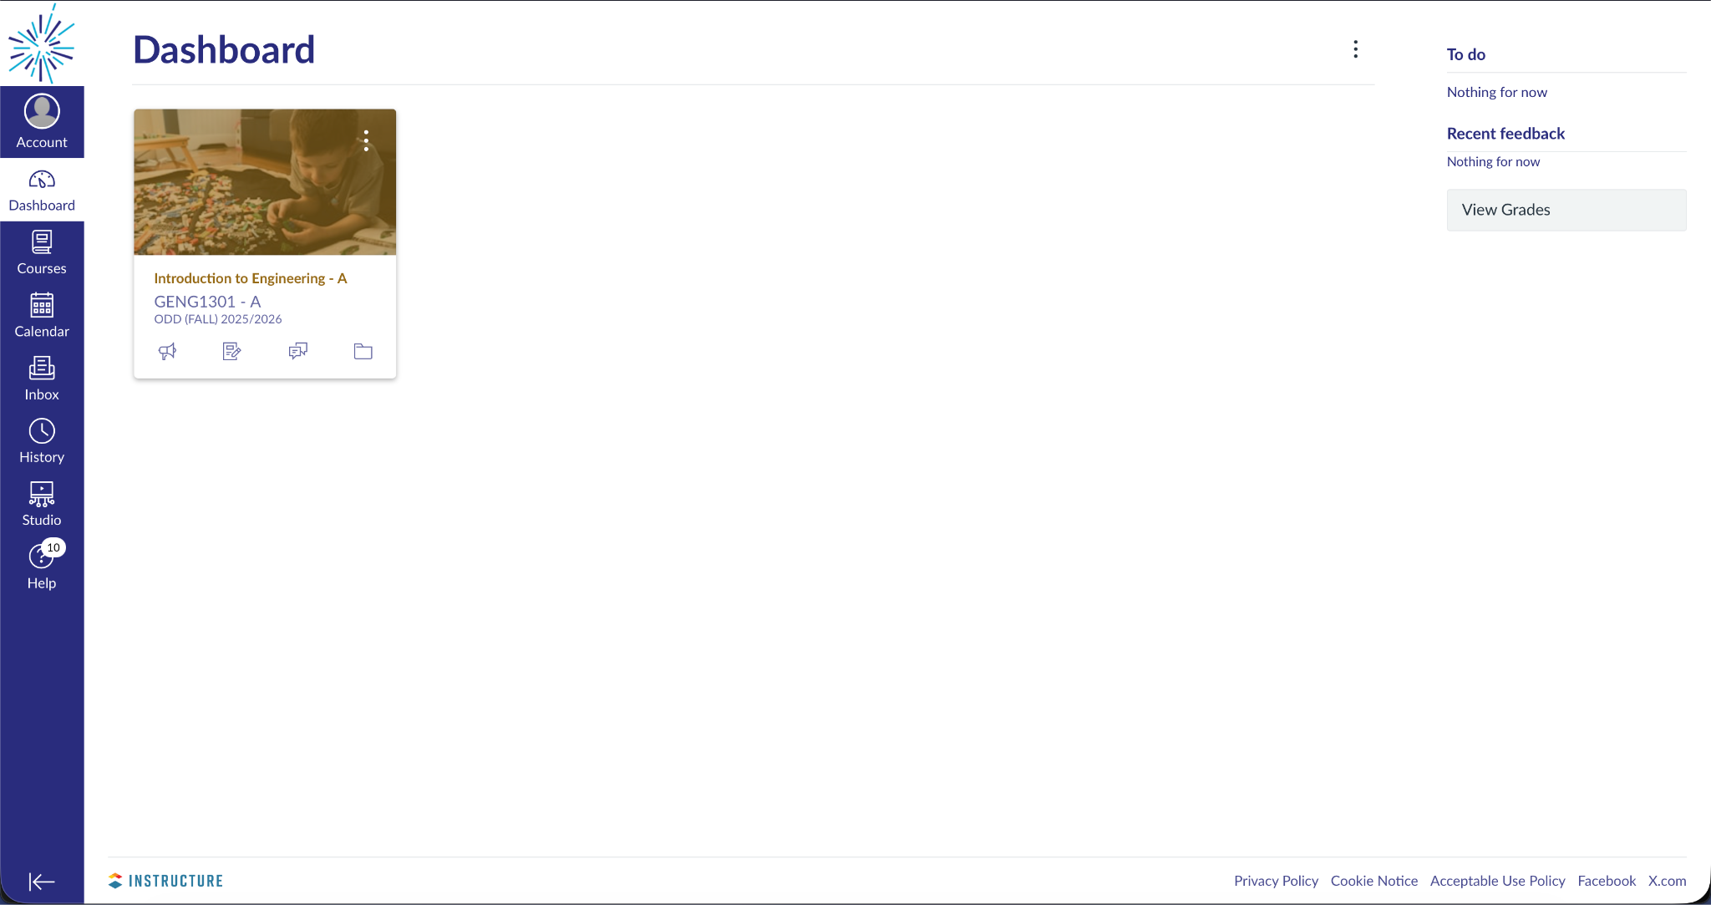

Student Portal
The Student Portal is the university's academic information system used for administrative and academic purposes. Students should be introduced to the portal for:
- Viewing semester grades and academic transcripts.
- Viewing degree plan (curriculum)
- Registering for courses during the course enrollment period.
- Completing post-teaching verification and other required academic evaluations.
- Accessing essential academic records and student-related services provided by the university.
Sampoerna University Student Portal Interface: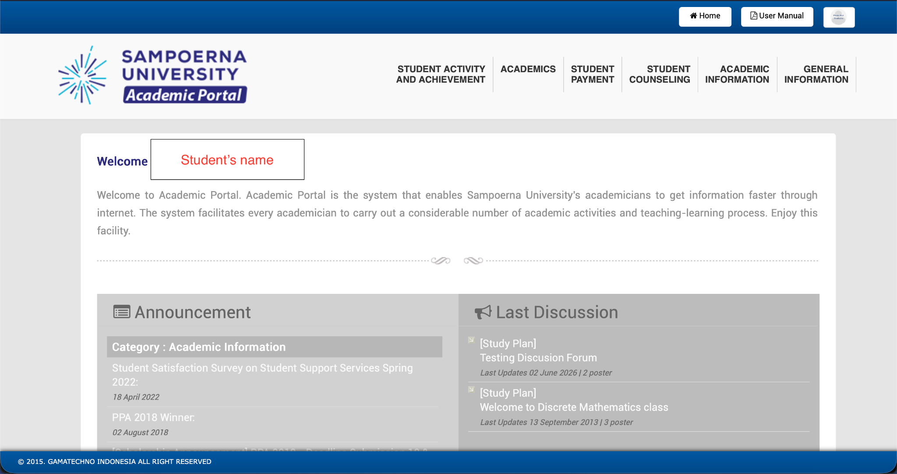

Group 2: Academic & Non-Academic Services

Academic & Non-Academic Services

🎓 Academic Services
SPAC (Student Parent Academic Counselor)
Provides academic guidance and support throughout a student's study period. Services include course planning, consultation on academic performance or grade-related concerns, assistance when academic issues cannot be resolved with the course lecturer, and guidance for students considering a change of major or seeking advice regarding their academic journey.
Note: You can visit SPAC office inside the library (on the 6th floor)
AR (Academic Registry)
Responsible for academic administration and official documentation. Services include the issuance of academic transcripts, enrollment verification letters, and other official academic documents.
Note: You can visit AR on 19th floor Left of the elevator hall just on the right. In front of class (19F-19)

📋 Non-Academic Services
Bursary
Handles financial and tuition-related matters, including tuition fee inquiries, payment procedures, and installment/payment plan requests for students who require greater financial flexibility.
Note: You can visit Bursary on 19th floor
SAA (Student Alumni Affairs)
Supports student life outside the classroom by overseeing student organizations, campus events, leadership opportunities, internships, and alumni relations. The office also facilitates the borrowing of the university alma mater jacket, provides information regarding extracurricular involvement, and career development services.
Note: You can visit SAA office on 6th floor (the office on the right side from the lift)

Group 3: Freshman Tips
FRESHMAN SURVIVAL GUIDE

Transition to University

Culture Shocks
- More freedom and flexible scheduling, but also far more personal responsibility.
- Stepping out of your comfort zone becomes something you have to do far more often than before.
- There are a lot of things that you need to adjust in the transition period, so get to know your seniors! We're approachable and are willing to help, so don't be afraid to reach out.

Dealing With Homesickness or Feeling Overwhelmed
- Consistently contacting your family and friends through video calls.
- Finding comfort food helps more than expected.
- Give yourself a stress outlet such as exercise, a hobby, journaling, resting.
- If distance allows, you can go home on weekends to rest and meet family.

Studies & Academics

Study Habits & Time Management
- Do the most urgent thing first.
- Use small gaps between classes for quick tasks, not your phone.
- Reward yourself after finishing tasks to stay motivated.

Find your most suitable study method according to your liking, everyone has different preferences.
- Studying with people who keep you accountable makes consistency easier. Combine studying and socializing where you can.

Choosing Electives
- Be alert during registration periods, sleeping in can land you in classes you didn't want.
- Don't load up on too many credits (SKS), leave some room to engage in activities and rest.
- Research a course's workload and difficulty before enrolling, and know each course's credit “weight” so you can prioritize.

Money Management Tips

What’s Actually Worth It?
- Most commonly wasted on: food delivery and eating out, impulse hobby purchases, and FOMO-driven outings.
- Worth buying instead: daily-use items like a laptop stand, mouse, earphones, and water bottle, dorm essentials (cookware, cutlery, blanket, umbrella), a power bank if you commute, and an e-money/TJ card.

Allocating Your Allowance
- Split your allowance into categories or “pockets” (needs, savings, entertainment) as soon as it arrives, rather than spending first and saving what's left.
- Immediately move a portion straight into savings or small investments before you spend it.
- Track spending with a spreadsheet or app or set a firm budget.
- Favor public transit (TJ/transum) over ride-hailing apps to keep daily costs down.
- Cheap food: PanBar (Pancoran Barat), Oma Lieke, and Warteg B1

Final Thoughts
University is one of the few stages in life surrounded by countless chances to learn, fail, meet new people, and discover who you are. Some of the most valuable things you gain won't show up on a transcript — they come from the people you meet, the challenges you overcome, and the mistakes you learn from. Your GPA matters, but it's only one part of the journey.

Group 3: Transportation

Transportation
- Transportation: Use Google Maps, Moovit, or the TJ app and get an e-money/TJ card.
- Recommended cards: e-money (Mandiri), Flazz (BCA), or Brizzi (BRI) — pick based on your bank. Note: cards issued by Bank DKI can only be used for Transjakarta, not for toll roads or parking.
- Far Distance Transportation : KRL, MRT and LRT; there’s an LRT close to our campus!
- Closest busway stops: Perdatam (near the BPJS office) and Tria Dipa (in front of Mixue) — both served by bus 9D (Ps. Minggu – Tanah Abang, both directions) and 4B (Manggarai – UI, both directions).
- Closest LRT station: Pancoran Bank BJB.
- MRT and LRT require a minimum card balance of Rp20,000.
- ada yg min 10k (pls clarify thanks)

